# Aromy

TECHNICAL DOCUMENT FOR AROMY V 0.2

## **Team One10**

11/10/2022

Cassandra Tong

**pton0008@student.monash.edu**

Client Liason

Shangqian Du

**sduu0007@student.monash.edu**

Developer

Daniel Phelan

**dphe0001@student.monash.edu**

Writer and Developer

Rui Qin

**rqin0002@student.monash.edu**

Developer

Eugene Aquino

**eaaqu1@student.monash.edu**

Technical Writer

# Executive Overview

This document is the Technical Document for Aromy’s web application. Within this document, you will find essential information for both users of the system and future maintenance teams. After reading this document, you will understand the structure and concepts underpinning the system. The compilation of this document was completed by 8 members involved in the design of the web application.

A brief outline of the parts of this document can be found below:

* Welcome
* Overall System Introduction
* High-Level System Architecture Diagram and Explanation
* System Technical Guide
* Development Environment
* Deployment Documentation
* Appendix (including essential diagrams about certain processes of the application and references)

Within each part, clear descriptions, GIT links, screenshots and diagrams will be used to illustrate and encourage a comprehensive understanding of the web application. Users reading this document will be guided through the development team’s approaches and they will be taught how to access the code-based structure for future use and maintenance.

# 

# Table of Contents

**Aromy** **0**

Team OneTen 0

**Executive Overview** **1**

**Table of Contents** **2**

**Welcome** **3**

Getting Help 3

Quick Start 3

**Overall System Introduction** **4**

Cakephp Framework Versions 4

User Testing Approaches 4

**High-Level-System Architecture Diagram and Explanation** **4**

**System Technical Guide** **5**

Design Specification 5

Codebase Structure 6

**Development Environment** **7**

**Deployment Documentation** **9**

## 

# Welcome

The purpose of this User Documentation is to act as a manual and ensure that users of the system, present and future, have a resource and reference of non-obvious business processes to refer to when using their system.

## Getting Help

If you have any questions or problems, please do not hesitate to contact our team members:

Name < email >

Shangqian Du [sduu0007@student.monash.edu](mailto:sduu0007@student.monash.edu)

Name < email >

Name < email >

Eugene Aquino [eaaqu1@student.monash.edu](mailto:eaaqu1@student.monash.edu) >

## Quick Start

To download the last version of the source file, please download the file [**here**](https://git.infotech.monash.edu/UGIE/ugie-2022/team110/team110-app_fit3047/-/tree/master).

# 

# Overall System Introduction

## Cakephp Framework Versions

The Cakephp Framework version for the Aromy web application is Cakephp v4.0 with the support documentation provided on Cakephp cookbook 4.0

## User Testing Approaches

Please refer to the following document for user testing purposes:

[Runsheet Integrity Test - Google Docs](https://docs.google.com/document/d/1XVyZ8vYBDy82P6uZlvYxnGdxjH5SlNl8P53quBV15wc/edit#heading=h.nv3vcvtzc1uj)

# High-Level-System Architecture Diagram and Explanation

# System Technical Guide

In this section, you will find the technical details for maintaining and operating Aromy Distribution’s web application. This will include basic development strategy as well as the codebase structure.

## Design Specification

All databases follow the strict naming conventions of Cakephp. If any future updates are made to the system, please refer to [CakePHP Conventions](https://book.cakephp.org/3/en/intro/conventions.html) to ensure consistency.

The .php code on the front-facing side operates in a similar fashion to HTML files so in the event of future updates, the [CakePHP cookbook](https://book.cakephp.org/4/en/index.html) should be utilised as a reference. On the back end, the code is also majority php so the cookbook can also be used as a reference [here](https://book.cakephp.org/4/en/index.html), or for further details and information.

## 

## Codebase Structure

Throughout the below section, the development method of the Aromy Distribution web application will be covered. To ensure full understanding, familiarity with the [Cakephp folder structure](https://book.cakephp.org/3/en/intro/cakephp-folder-structure.html) is recommended.

Cakephp framework was used to construct the web application across three layers: Model, Controller and View. Using PHP or JavaScript the Controller controls the functionality of the website. Model controls data access from phpMyAdmin. Finally, the View Layer’s responsibility is to generate specific output required for the request, following the Layout file. For table constraints and relationships, please see ERD.

Controller, Model and View are covered in detail below:

**Controller**

This layer sits between Model and View and its purpose is to handle the user request and ensure that the correct models are brought forward and that the correct view is visualized.

**Model**

This layer, Model, represents data and manipulates it through tables, objects and entities—the two primary object types. Everything regarding the data can be worked through and molded through these objects.

**View**

The view layer shows the model data to the user and allows them to modify it through an interface. This particular layer combines PHP, HTML, CSS and JavaScript so that the model and controller can be clearly illustrated.

**Webroot**

Webroot is the container for CSS, Javascript and Images files of the website.

* .../webroot/CSS: contains all the css files responsible for layout of the website.
* .../webroot/js: includes all javascript files of the website. Also refer to <script> at each page for specific javascript applied.
* .../webroot/img: all the images used by websites are stored within this folder. This includes what is on the database.
* .../webroot/vendors: contains the css and javascript of all the effects on the website, sorted by folder.

# Development Environment

It is highly recommended to have CakePHP ver 4.0 installed as a stand-alone application before downloading the complete package from the provided location, given the application is built on the CakePHP framework. We recommend this to prevent any conflict if it directly downloads the complete package (eg: gitignore file will disregard some files, etc).

CakePHP applications (both building and running them) require a web server that runs PHP as well as a supported database. We recommend using the built in and MySQL as both are widely used and can be used for commercial and non-commercial purposes for free. To install and run a CakePHP application, please follow the instructions in the CakePhp [installation guide](https://book.cakephp.org/4/en/installation.html)

The recommended tools for assessing include:

1. PHPStorm
2. XAMPP [Local host includes Apache & MySQL database]
3. Google Chrome
4. GitLab

After the local environment is set up, please download the compressed file **here**.

It is important to set up the database as well to run CakePHP on your local development environment. Please see instructions for this below.

1. Open XAMPP and start Apache & MySQL then click on “Admin”. Alternatively, go to your desired cPanel and open your choice of control panel for the database. Create a table with your choice of name.
2. Download the **SQL** file here and import it into your desired database

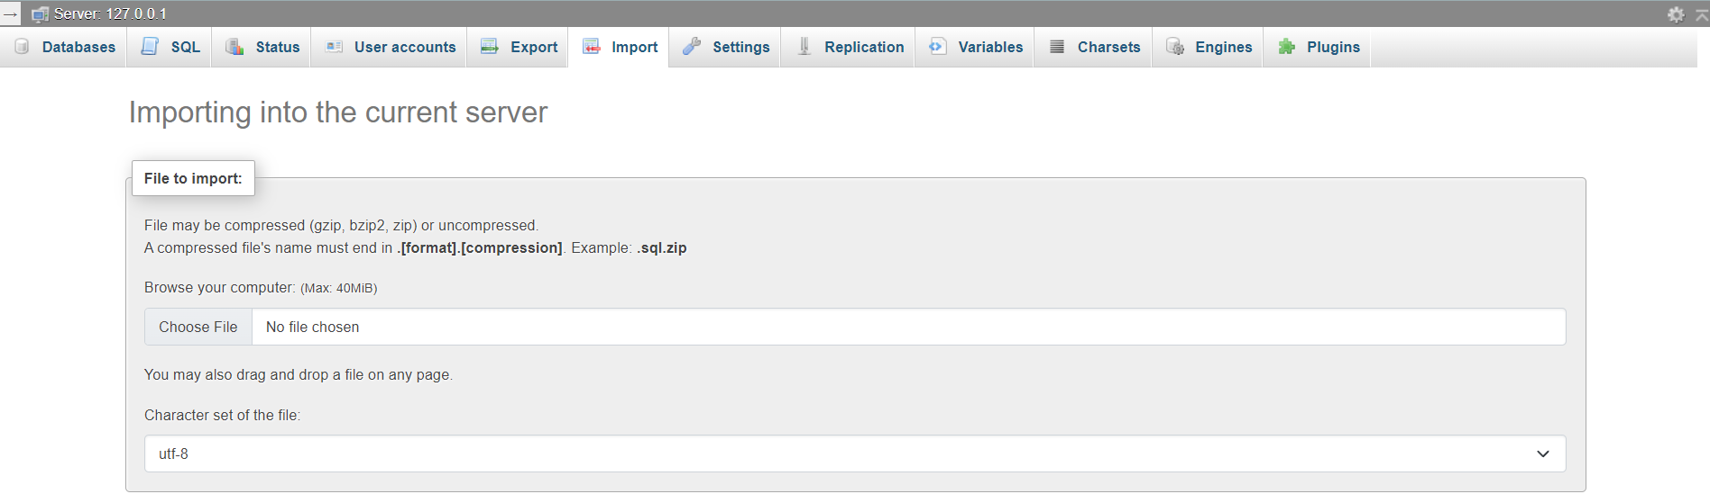

1. After clicking go, it will bring you to a page indicating the successful upload of the file into your database
2. Locate app_local file within config folder and replace the values for the following:
   1. Username
   2. Password
   3. Database

To be in line with the newly created database and users.

1. Open your browser and type in ‘localhost/’ and follow the filepath to access it.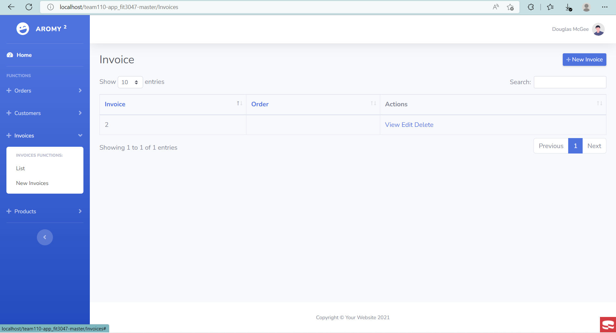

Shown above is the filepath from the localhost as the URL.

# Deployment Documentation

This section will provide instructions on deployment of the web application to the live server. This also includes designating the development git repository to the live server and setting up the database.

Web-application deployment:

1. Login to cPanel using provided credentials
2. Open the terminal and clone the repository

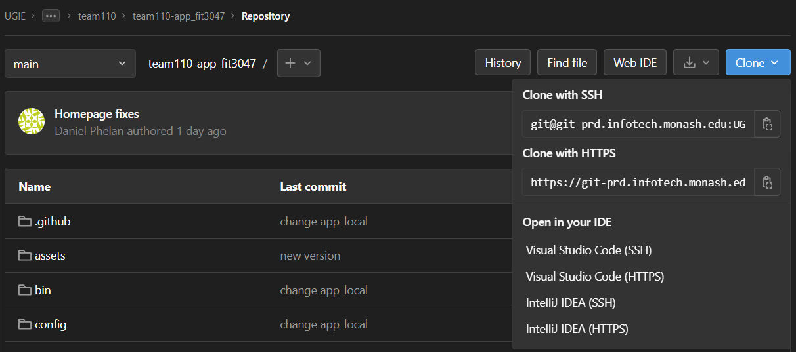

1. Create a subdomain and point the root file to that sub-domain
2. Create a new database and create a user

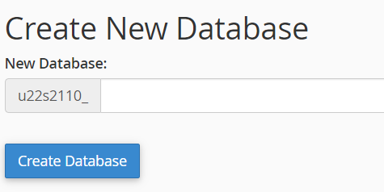

1. Create New User

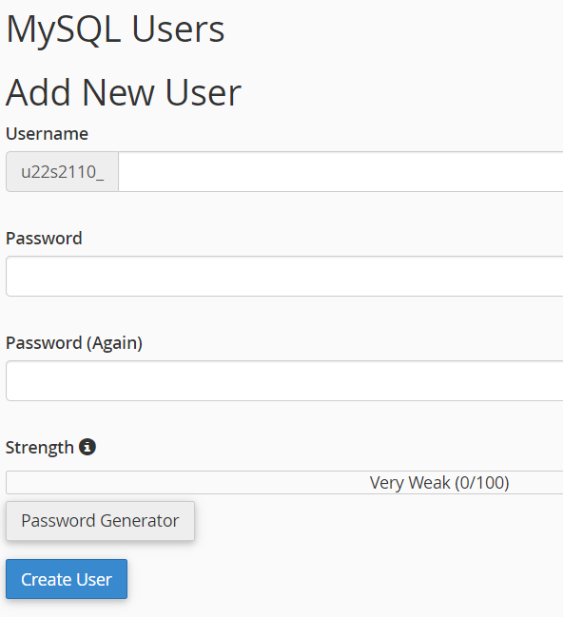

1. Connect user to Database

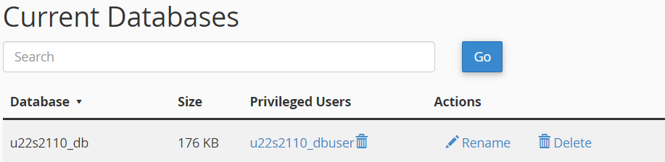

1. Export SQL file mentioned above and upload to your cPanel
2. Open Terminal within cPanel and run: composer install and follow the prompts
3. Locate app_local file within config folder and replace the values for the following:
   1. Username
   2. Password
   3. Database

To be in line with the newly created database and users.

1. Disable debug page within app_local.